1.Add following under manifest tag to your AndroidManifest.xml:
<uses-permission android:name="android.permission.INTERNET"/>

2. Put the DispplyAdSDK-1.0.2.aar in “libs” folder in your Android Studio
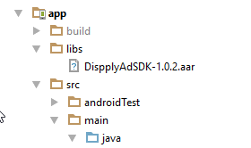

3. Add it to dependencies in build.grandle file with “flatDir” repository. Also you need to add google play services.

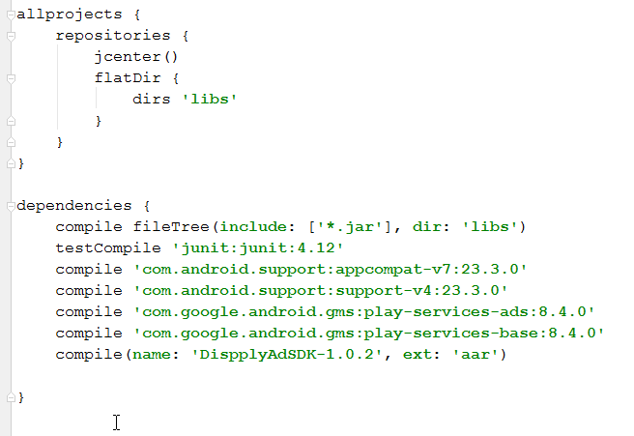

4. Then, create a function that requests a native ad:

private void loadInterstitialAd() {
interstitialAd = new InterstitialAd(this, getString(dispply.com.dispplyadssample.R.string.adPlacement)); //Interstitial AD constructor
interstitialAd.setAdListener(new InterstitialAdListener() { // Set Listener
@Override
public void onAdLoaded(com.dispply.lib.sdk.interstitialads.Ad ad) { // Called when AD is Loaded
iAd = ad;
Toast.makeText(MainActivity.this, "Interstitial Ad loaded", Toast.LENGTH_SHORT).show();
}
@Override
public void onError(com.dispply.lib.sdk.interstitialads.Ad Ad, String error) { // Called when load is fail
Toast.makeText(MainActivity.this, "Interstitial Ad failed to load with error: " + error, Toast.LENGTH_SHORT).show();
}
@Override
public void onInterstitialDisplayed() { // Called when Ad was impressed
Toast.makeText(MainActivity.this, "Tracked Interstitial Ad impression", Toast.LENGTH_SHORT).show();
}
@Override
public void onInterstitialDismissed(com.dispply.lib.sdk.interstitialads.Ad ad) { // Called when Ad was dissnissed by user
Toast.makeText(MainActivity.this, "Interstitial Ad Dismissed", Toast.LENGTH_SHORT).show();
}
@Override
public void onAdClicked() { // Called when user click on AD
Toast.makeText(MainActivity.this, "Tracked Interstitial Ad click", Toast.LENGTH_SHORT).show();
}
});
interstitialAd.loadAd(); // Call to load AD
}
public void showInterstitial(View view) {
if (iAd != null)
InterstitialAd.show(iAd); // Call to show AD
else
Toast.makeText(this, "The Interstitial AD not ready yet. Try again!", Toast.LENGTH_LONG).show();
}
The SDK will log the impression and handle the click automatically.

